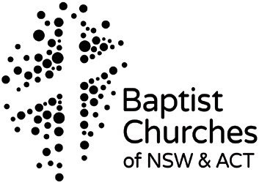
Approval for Ministry
This is a written accountability tool for ensuring that you have done your risk management and are ready to run your program for the year/semester/or event.
Church name: Name of program: Where the program / event takes place: Time of program: Ministry coordinators: Program leader’s name: Contact Ph: Times available to the team: Name: Contact Ph: Times available to the team: Program first aid person: Emergency numbers: Ambulance: Local fire brigade: Local police: Safe Church Contact Person:

Complete (and attach where appropriate) the following:

Team list (team is large enough to safely run the program)

Team have been trained, or will attend Creating Safe Spaces training this year. Team have been properly recruited & forms filed at church
Housekeeping Risk Assessment Checklist completed

Individual program risks have been assessed and negated or minimised; safety plans for individual program risks attached

Participant information gathered

All notes for permission prepared &/or collected (as necessary) Program attached (as appropriate)

